HW4 MSDAP Design Specification
CE6306
Lamin Jammeh (DAL852207) CALEB PEREZ (CXP180012)

Spring 2025
1)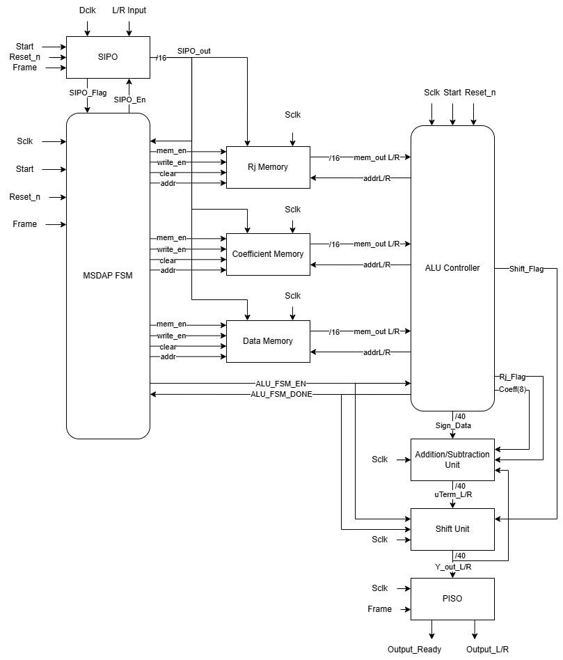
Figure 1: MSDAP Block Diagram

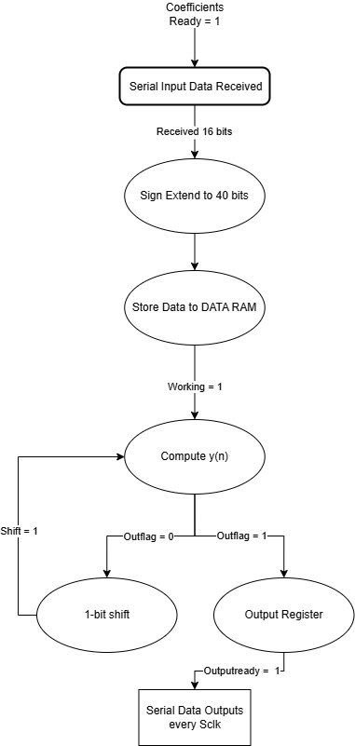
Figure 2: MSDAP Controller FSM
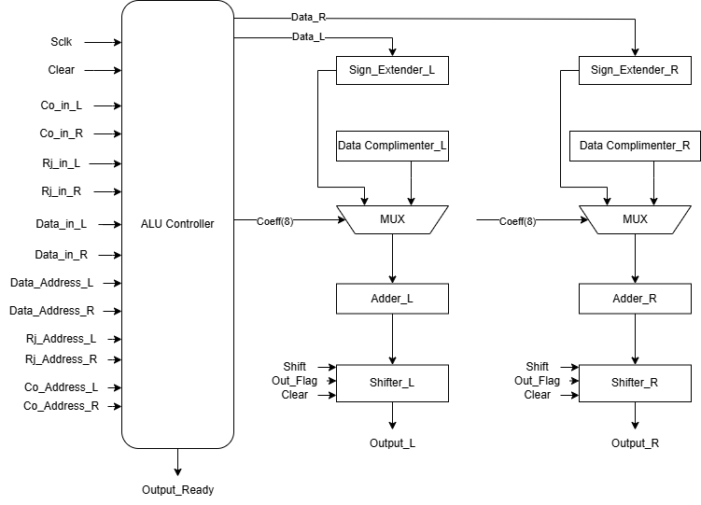
Figure 3: ALU Block Diagram
  - Provide a written explanation of the reasons why you chose your microarchitecture.

The decision to split the system into two parts (Datapath and Controller) comes from de-obscuring the duties of specific blocks. The data path is solely responsible for storing, manipulating, and transferring data. The controller provides the command for these operations.

The system is synchronous and Top-down. Top-down design is appropriate for this project because we do not have a set library of components to choose from. Instead, we are designing our blocks based on the specification.

The system block diagram is broken into two parts. The data path, and the controller. The controller facilitates data frames, start, and stop operations. The MSDAP FSM facilitates data from the SIPO block to the memory blocks, and then through the ALU controller and into the addition/subtraction unit, shift unit, and then finally into the PISO block.

2) Interface Control Block:
This is the Main IO controller for the ASIC. The block is run by a Finite state machine (FSM). The Interface Control Block will have the following connections.
- Reset_n: this is an Input that will clear all the 3 memory registers (Rj, Coeff, Data_in)
- Frame: frames the first bit that comes through the InputL/R
- Start: this initializes all the input ports and the output/result register or
- Sclk: signal clock
- S2P enables this is normally high until the memory registers are full.
- S2P_hold: 4bit register that will be connected to the 3 memory registers to indicate if any of the memories are full
- Rj_enable
- Rj_write
- Rj_clear
- Coeff_enable
- Coeff_write
- Coeff_clear
- Data_enable
- Data_write
- Data_write

Serial to Parallel Block (S2P)
This block only controls the data input to the memory registers. The Start, Reset_n, and Frame are branched from the interface control block, the following ports are independent ports to the S2P.
- Dclk: data clk controls how the input bits are coming in the S2P block. A 4 clk cycle gap indicates that the data package is complete, and the next bit after that is the beginning of a new set of data.
- InputL/R: this port accepts all incoming data that are destine for memory Block
- S2P_out: this port will transfer the data to the various memory registers using the following logic.
  - If the data package is 8bit the data will be destined to the Rj_memory block
  - If the data package is 9bit the data will be destined to the Coeff_memory block
  - Else the data package will be destined to the Data_in memory block
- Additionally, we have the S2P_enable and S2P_hold: these ports come from the Interface control block
RJ Memory:
This is a 16x8 register, the address bit is 16bits (16 row memory) and each address can hold 8bits (8 column for each row). The Rj will behave as the filter tap or stage, the value in the address row will determine how many coefficients will be used to perform the FIR convolution.
Rj Memory operation:
When the memory is full the following sequence is triggered
- Rj_enable= 1b_0
- S2P_hold = 3b_001 //indicates Rj memory is full
When there is an empty address row in the Rj memory the following sequence is triggered
- Rj_enable = 1b_1
- S2P_hold = 3b_000 //indicates Rj memory is not full
The ALU control block will call for an address and the Rj memory will send the content of that address location. The ALU will use the content of the Rj row address to determine which Coeff Memory addresses will be used to perform the convolution. The following ports are connected to ALU Control
- Rj_OutL/R
- Rj_addrL/R

Coeff Memory:
This is a kx8 register, the address bit is k-bits (k is the total number of cycles for the filter) and each address can hold 9bits (9 column for each row).
Data handling in the Coeff Memory:
- The MSB which will the first bit (big endian form) of any 9bits data package received through port inputL/R will be treated as the sign bit for the Data_in sample.

  - If the MSB = 0 use the positive Data_in sample
  - If the MSB = 1 use the 2’s complement of the Data_in sample

- The rest of the 8bits of in the row address (8th bit to LSB) will be used to determine the k value a that computation step
  - If k = 14 then the Data_in sample will be x(n-14) where n is the Data_out to determined.
  - Note Data_out = y(n)
Coeff Memory Operation:
When the memory is full the following sequence is triggered
- Coeff_enable= 1b_0
- S2P_hold = 3b_011 //indicates Coeff memory and Rj memory are full since the Coeff is depending on the Rj, therefore Rj memory needs to be full first before coeff memory become disable
When there is an empty address row in the Coeff memory the following sequence is triggered
- Coeff_enable = 1b_1
- S2P_hold = 3b_000 or 3b_001 //indicates Coeff memory is not full
The ALU will use the contents of the Rj memory to determine which Coeff_addrL/R rows to call for at each Rj stage. The content of the Coeff_addrL/R will de used to determine which Data_in sample will be used for the convolution. The following ports are the connection between the Coeff_memory and the ALU control block
- Coeff_OutL/R
- Coeff_addrL/R

Data_in Memory:
This is a nx16 register, the address bit is n-bits (n shows the number of possible samples for the ASIC). Each address row will hold 16bits, the ALU controller determines which address of the Data_in memory will be used.
Data_in Memory Operation:
When the memory is full the following sequence is triggered
- Data_enable= 1b_0
- S2P_hold = 3b_100 //indicates that the Data_in memory is full and can no longer take more Data_in samples
When there is an empty address row in the Coeff memory the following sequence is triggered
- Data_enable = 1b_1
- S2P_hold = 3b_011 or 3b_001 //note the Rj has to be full before any other start accepting data
No data manipulation is perform at the Data_in memory all bit extensions, shifting, and other arithmetic operation are handled at other registers. The following two ports are used to communicate with the ALU controller at Data_in Memory.
- Data_OutL/R
- Data_addrL/R
ALU Controller:
This block will control all the arithmetic operations of the ASIC. The block will control the Accumulator, Add/Sub block, and shift block on the downstream side; the memory registers are on the upstream side of the ALU controller.
The Sclk, Start, and Reset_n are branching to the ALU controller, enable and done signal for the ALU are connected to the Interface Control Block, since the main FSM machine is located at the interface block.
Accumulator:
This is a 1x40bit reg that stores the current result of the computation from the Shift block. Acccumulation is needed because some Rj values might trigger the convolution of multiple Data_in samples. If this happens the results from the previous computation are Add/Sub with the current content of the Accumulator, once ALU is done the accumulator is sent to Parallel in Serial Out (P2S)
Add/Sum Block and Shift Block:
These blocks will be used for computation. The shift block is a 1-bit shifter, while the Add/Sub will take the sign_data and the accumulator content as input and outputs a 40bits data.
P2S Block:
This is responsible for outputting the final data in the accumulator once ALU signal is sent to the Interface Block
3)
The article highlights the use of Large Language Models (LLMs) in the writing of Verilog code, firmware code, and hardware/software test cases. Using LLMs enables rapid development of tape-out-ready SoCs, in this case a 2-month design time.
The exploration into using LLMs for hardware generation included a “tuned” version of OpenAI’s GPT-2 to develop basic Verilog code snippets. LLMs like GPT-2 and onward were fine-tuned using a novel dataset called “VeriGen” with data from GitHub and Verilog textbooks. They found that this data-specific LLM outperformed GPT-3.5 in a variety of benchmarks. The updated GPT-4 outperforms the “tuned” version of GPT-2, probably due to performance increases on the backend of the GPT-4 model. In this example, they use GPT-4 without fine-tuning it, as they found the performance acceptable.
The Vector co-processor’s high-level architecture was designed by humans. The instruction set architecture was developed by GPT-4 and tuned by humans to ensure that the implementation was feasible and properly scoped. GPT-4 was used to generate the SystemVerilog code for all hardware blocks and architectures. Lastly, GPT-4 was used to generate the system software and test cases.
Each hardware block design problem is seeded with a prompt that summarizes the functionality of the block. The prompt usually includes the blocks interfaces, including bit widths, and its functionality. Test benches are comprised of unit tests that exercise the functionality of the block. The test benches are used to refine the generated blocks until the desired functionality is met. The test benches are generated in python code, since GPT-4 is less prone to errors when coding in Python, then it is translated to SystemVerilog.
To have GPT-4 generate the firmware, two C libraries that provide users with the ability to use vector and matrix operations were used. This made it easier for GPT-4 to manipulate and interface with vector-vector and vector-scalar integer and floating-point operations.
The paper highlights some best practices for prompts so that you get the best responses from GPT-4. The authors state that it was “impossible” to generate modules above a certain level of complexity. They further state that the “context window” of GPT-4 was limited. It was harder to develop designs with more code. They take the approach of partitioning their blocks into simple submodules and recursively designing, verifying, and composing the subblocks into larger modules. They state that GPT-4 would refuse to write code past a certain length, regardless of the prompt. This was a huge problem with the decoder, as it was an especially large module. They broke the decoder down into small pieces and were able to derive a larger module.
In all, LLMs seem to be a useful tool in developing simple, small, modules. The idea that LLMs can replace designers completely is silly, but I do think this is a helpful tool for streamlining code and testbench development.
Attempts will be made to utilize AI generated code in our project, but proper validation measures will have to be taken before assuming that the blocks are ready for layout.

